**Institute of Engineering & Technology**

**Devi Ahilya Vishwavidyalaya, Indore**

**Department of Computer Science & Engineering**



**Object Oriented Programming (CER3C2)**

**Assignment-1**

**(Simple Java Programs)**

**Submitted To: Submitted By:**

**Harshita Sharma Mam Tanishq Chauhan (21C3184)**

**CS-Dept CS “B” 2nd Year**

**IET-DAVV**

**Assignment-1**

1. Write a program to draw a pyramid of star.

class PyramidStar{

    public static void main(String[] args) {

        int n=5;

        for(int i=0; i<n; i++){

            for(int j=n-i; j>1; j--)

            {

                System.out.print(" ");

            }

            for(int j=0; j<=i; j++ ){

                System.out.print("* ");

            }

            System.out.println();

        }

    }

}

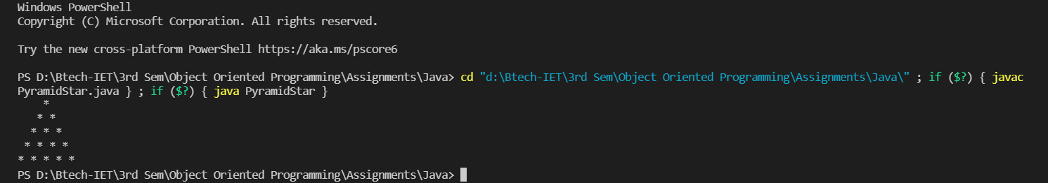**Output**

1. Write a program to display the list of even numbers between 1 to 100.

public class Even_No {

    public static void main(String[] args) {

        for(int i=1; i<=100; i++)

        {

            if(i%2==0)

            {

                System.out.print(i+" ");

            }

        }

    }

}

**Output**



1. Write a program to display prime numbers between 1 to 200.

public class Prime_No {

    public static void main(String[] args) {

        System.out.println("Prime Number Between 1 to 200 is: ");

        for(int i=1; i<=200; i++)

        {

            int count=0;

            for(int j=i; j>=1; j--)

            {

                if(i%j==0)

                {

                    count++;

                }

            }

            if(count==2){

                System.out.print(i+" ");

            }

        }

    }

}

**Output**

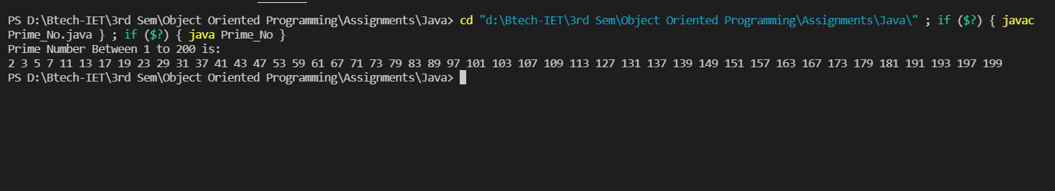

1. Write a program to find sum of all integers greater than 100 and less than 200 that are divisible by 7.

public class Divisibleby7 {

    public static void main(String[] args) {

        int sum=0;

        for(int i=100; i<=200; i++)

        {

            if(i%7==0){

                sum=sum+i;

            }

        }

        System.out.print("Sum of all integers is :"+sum);

    }

}

**Output**

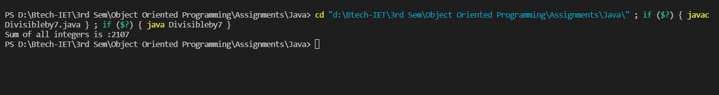

1. Find minimum and maximum of two numbers using conditional operator.

public class Min_Max

{

    public static void main(String[] args)

    {

        int a=10;

        int b=17;

        if(a>b)

        {

            System.out.println("The Maximum of Two Number is:"+a);

            System.out.println("The Minimum of Two Number is:"+b);

        }

        else

        {

            System.out.println("The Maximum of Two Number is:"+b);

            System.out.println("The Minimum of Two Number is:"+a);

        }

    }

}

**Output-1**

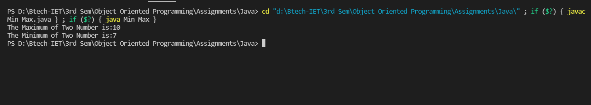

**Output-2**

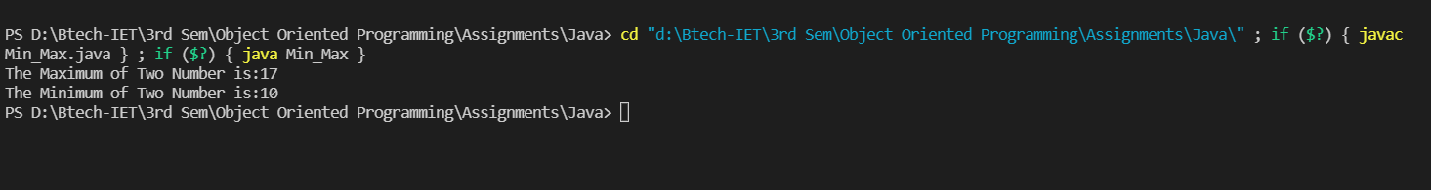

1. Create a class Circle and methods circumcircle( ) to compute circumference of a circle and arcLength() to compute the length of the arc for a given angle. Within the main method of class Circle create an object which compute circumference when the radius is 10 and arc length when the angle is 45.

public class Circle {

    public static void circumCircle(double radius)

    {

        double circumference=2*3.14*radius;

        System.out.println("The circumference of circle with radius " + radius + " is " + circumference);

    }

    public static void arcLength(double radius, double angle)

    {

        double arc= (radius*angle*3.14)/180;

        System.out.println("The length of arc of circle with radius " +radius+ " and angle " + angle+ " is " + arc);

    }

    public static void main(String[] args)

    {

        circumCircle(10);

        arcLength(10,45);

    }

}

**Output**

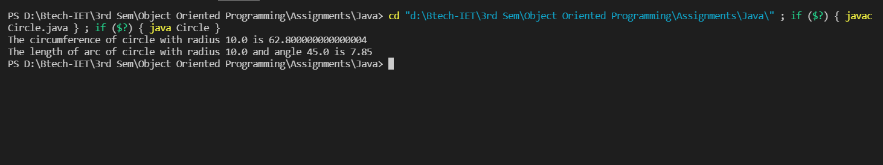

1. Write a program in which class is declared to deal with the characteristics of regular polygons and declare methods for determining area and parameter. The length of the side and the number of the sides should be declared public.

public class Polygon {

    static void area(double n, double length)

    {

        double angle= Math.toRadians(180/n);

        angle=Math.tan(angle);

        double Area=(length*length*n)/(4*angle);

        System.out.println("The area of polygon with "+ n + " sides is "+ Area);

    }

    static void Perimeter(double n, double length)

    {

        double perimeter=n*length;

        System.out.println("The perimeter of polygon with "+ n + " sides is "+ perimeter);

    }

    public static void main(String[] args)

    {

        area(6, 10);

        Perimeter(6, 10);

    }

}

**Output**

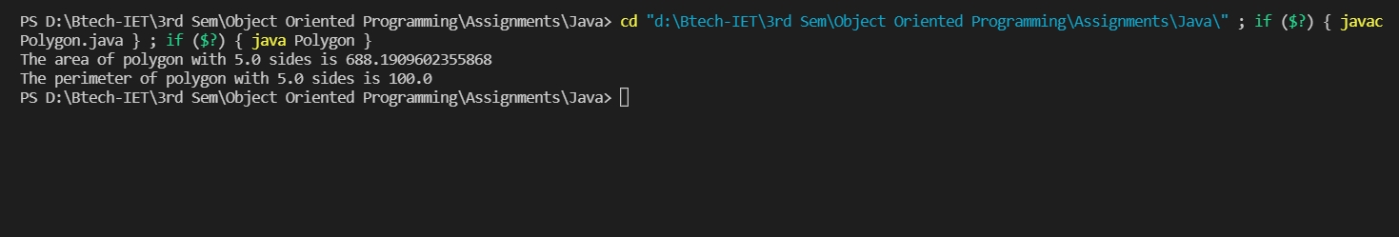

1. Write a program to generate 5 random numbers between 1 to 100 and it should not follow with decimal point.

import java.util.Random;

public class GenerateRandom_No {

    public static void main(String[] args) {

        Random obj=new Random();

        System.out.println("Random number between 1 to 100");

        int upperbound=101;

        for(int i=1;i<=5;i++){

            System.out.println(i + " Random Integer Between 1 to 100 is: " + obj.nextInt(upperbound));

        }

    }

}

**Output**

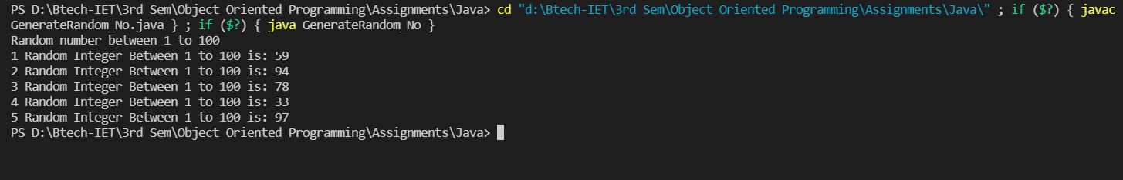

1. Write a program in which a sample of 8 random numbers are generated and an average value is determined by a user.

import java.util.Random;

public class RandomAverage

{

    public static void main(String[] args)

    {

        int sum=0;

        Random ran =new Random();

        System.out.println("Random Numbers are: ");

        for(int i=1;i<=8;i++)

        {

          int x = ran.nextInt();

          System.out.println(x);

          sum = sum+x;

        }

        int average = sum/8;

        System.out.println("Average of 8 Random Numbers is: "+ average);

    }

}

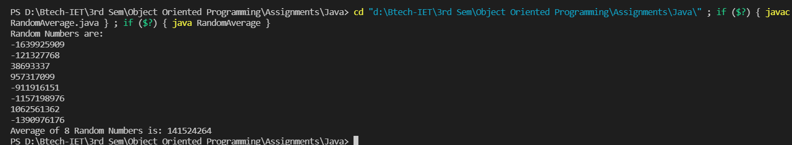**Output**

10.Write and run a java program that generates a random integer in the range of 60 to 99and then prints the letter grade that would be correspond to that score on a test. Divide the marks interval 60-99 into 9 intervals and grade them A+, A, A-, B+, B, B, C+, C, C-.

import java.util.Random;

public class Grade {

    public static void main(String[] args) {

        Random random = new Random();

        int innerbound=59, upperbound = 100;

        int rand = random.nextInt(innerbound, upperbound);

        System.out.println("Random integer between 60 to 99 is: "+ rand);

        if(rand>=60 && rand<=63){

            System.out.println("The grade is C-");

        }

        if(rand>=64 && rand<=67){

            System.out.println("The grade is C");

        }

        if(rand>=68 && rand<=71){

            System.out.println("The grade is C+");

        }

        if(rand>=72 && rand<=75){

            System.out.println("The grade is B-");

        }

        if(rand>=76 && rand<=79){

            System.out.println("The grade is B");

        }

        if(rand>=80 && rand<=84){

            System.out.println("The grade is B+");

        }

        if(rand>=85 && rand<=89){

            System.out.println("The grade is A-");

        }

        if(rand>=90 && rand<=94){

            System.out.println("The grade is A");

        }

        if(rand>=95 && rand<=99){

            System.out.println("The grade is A+");

        }

    }

}

**Output**

